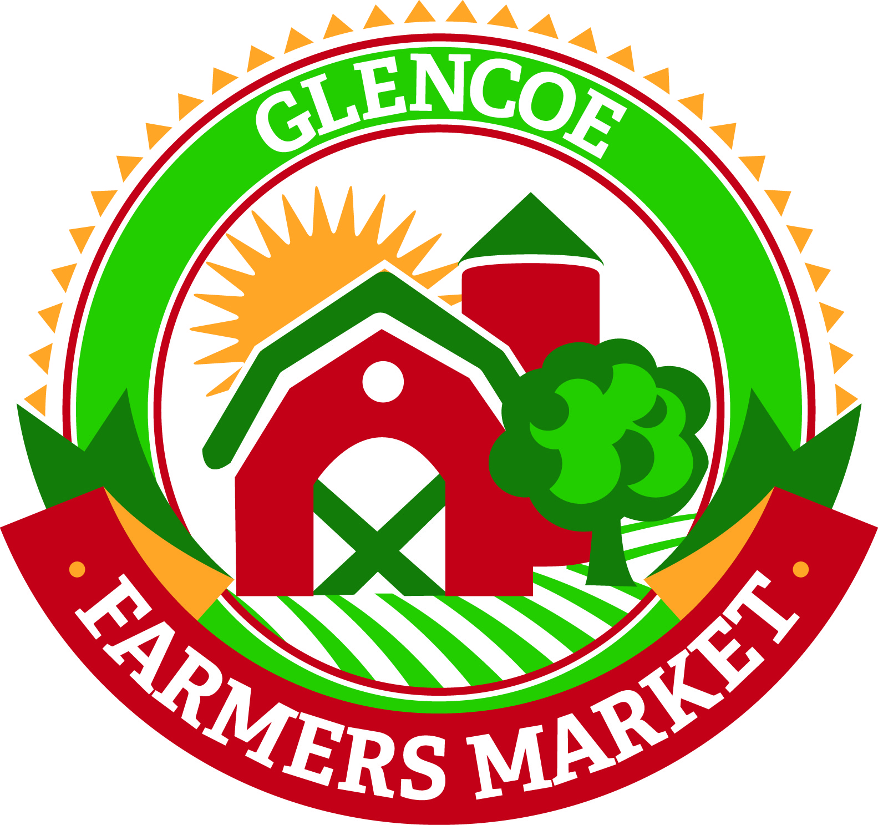
GLENCOE FARMERS’ MARKET
VENDOR GUIDELINES
LOCATED AT 11TH STREET & GREELEY AVENUE, GLENCOE

Season starts june 20, 2019 to october 17, 2019

- All vendors at the Glencoe Farmers’ Market shall abide by all rules and regulations adopted by the Glencoe Area Chamber of Commerce for the governance of the Market. Vendors in violation of any of the adopted rules shall receive one written warning. Any further violations shall result in the vendor forfeiting their seasonal pass. There will be no refund of any unused portion of the pass.

- It is the responsibility of the vendor to ensure that they follow all the appropriate licensing and guidelines requirements as outlined by the Minnesota Department of Agriculture Operational Guidelines.

- Fresh and/or prepared foods must be labeled homemade. A “Homemade Goods” sign will be available and is required to be displayed during each Farmers’ Market. Prepared foods must also be labeled with the name and address of the person preparing and selling the food items.

- Anyone giving out food samples must follow the MN Safe Food Sampling Law and attend the Safe Food Sampling at Farmers’ Market and Community Event Workshop.

- The Farmers’ Market opens at 3pm. No early sales are allowed. No pre-bagging or on-site pre-order taking on the day of the event is allowed.

- Vendors are encouraged to stay until closing, 6pm.

- No live animals may be sold at the Farmers’ Market.

- No pets or alcoholic beverages are allowed at the Farmers’ Market.

- Smoking is NOT allowed anywhere on the premises of the Glencoe Farmers’ Market during the set-up or operation hours.

- To sell by weight, vendors must have a scale that has been inspected and approved by

- There is a one-time charge of $75 to have a booth at the Farmers’ Market. This allows you to have a booth at every Farmers’ Market for the year. You may choose not to attend every week is you wish. No loaning or subleasing of your booth to others is allowed.

- Please be courteous to your fellow vendors and shoppers. Obscene language or shouting is not permitted. We want to make sure this is an enjoyable experience for everyone involved. Please clean up your area after the market closes.

- Do not throw unsold or spoiled produce in the park trash receptacles! Vendors are responsible for disposing of their trash.

- Vendors are asked to help present a pleasant and professional Farmers’ Market environment by directing concerns or complaints to the Chamber of Commerce Office rather than the on-site coordinator, vendors or customers.
WHAT CAN AND CAN NOT BE SOLD

- FRUITS AND VEGTABLES
  - Any HOME GROWN produce CAN BE SOLD.
  - Items purchased somewhere else CANNOT be sold at the market.

- BAKED GOODS
  - Any baked goods that DON’T NEED REFRIGERATION CAN BE SOLD.
  - Cream pies made with eggs CANNOT be sold at the market.

- CANNED GOODS
  - Items such as jams, jellies, and honey along with HIGH-ACID items such as horseradish, pickles, tomatoes, salsa, and pickled beets CAN BE SOLD.
  - LOW-ACID items CANNOT be sold at the market. Please see page 4 of the state guidelines for examples.

- CRAFTS
  - Any HOMEMADE crafts CAN BE SOLD.
  - Commercially produced items CANNOT be sold.

- FLOWERS AND PLANTS
  - Any legal HOME GROWN plants or flowers CAN BE SOLD.

- EGGS
  - Eggs CAN BE SOLD provided the vendor provides evidence prior to selling at the market directly to the Chamber of Commerce Office that he or she has obtained that the appropriate approval from the MN Department of Agriculture.
  - All eggs sold must be candled and graded. In addition, vendors must follow the MN Department of Agriculture labeling and refrigeration requirements.

- Poultry
  - Poultry CAN BE SOLD provided the vendor provides evidence prior to selling at the market directly to the Chamber of Commerce Office that he or she has obtained that the appropriate approval from the MN Department of Agriculture.
  - All poultry sold must follow the Minnesota Department of Agriculture processing, labeling, refrigeration and all other requirements.

- BEEF, SEAFOOD AND PORK PRODUCTS CANNOT BE SOLD!

Thank you for your interest in the Glencoe Farmers’ Market. Your involvement helps ensure its continued success. We are proud to be able to offer this unique shopping experience to the residents in the Glencoe area.

If you have any questions regarding this year’s Farmers’ Market, please contact the staff at the Glencoe Chamber of Commerce Office at (320) 864-3650.

Updated – 5/9/19

